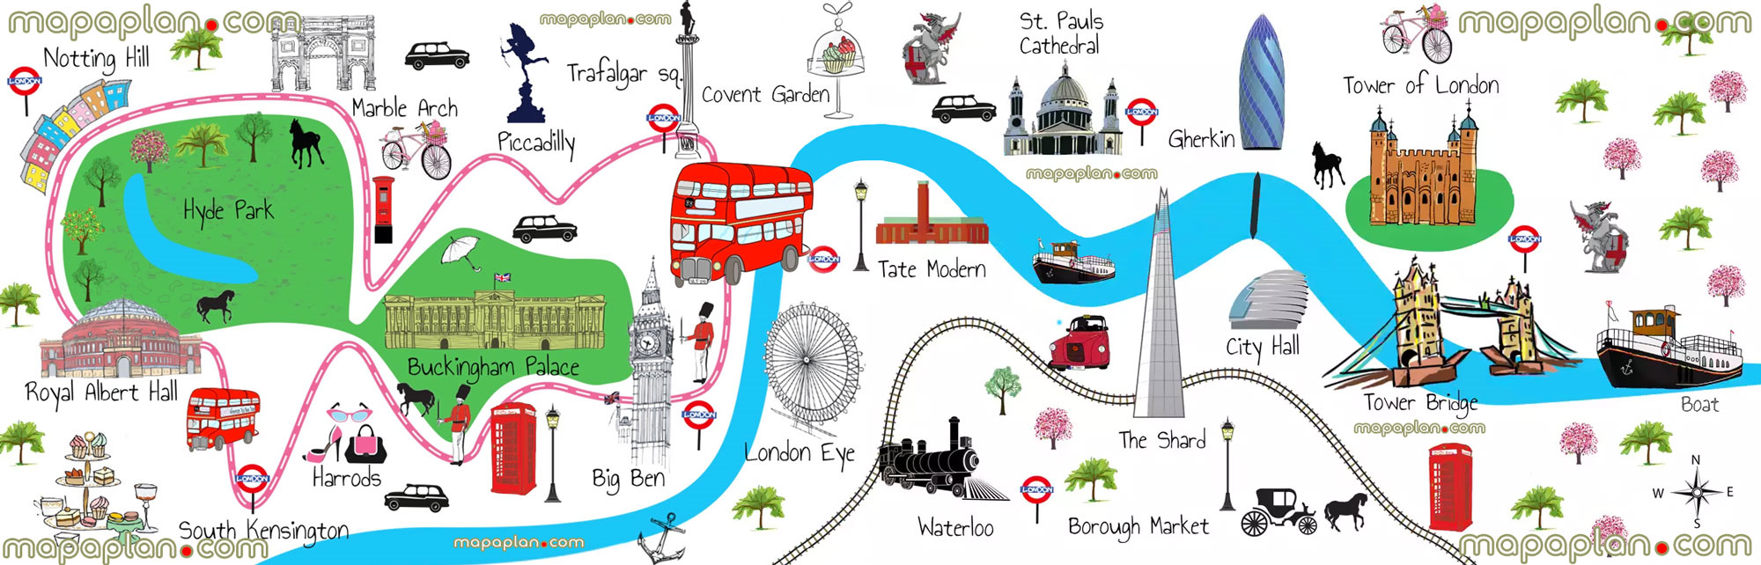

Welcome back! It is lovely seeing all the children so eager to learn. We hope you have all had a wonderful summer break and are looking forward to another busy term of building vehicles, making the houses of Pudding Lane and have a lovely guided walk around Calne.

Bright Lights Big City

The ‘Imaginative Learning Projects’ that we explore each half–term in KS1 are back and they are mapped closely to the coverage and requirements of the new national curriculum, whilst allowing our learners and teachers every opportunity for flexibility and creativity to steer a theme and pursue a topic wherever their interests lead.

This has enabled us to create exciting, engaging and meaningful cross-curricular links between programmes of study and different subject areas, whilst also developing and embedding the essential skills required of each and every child.

As writers, we will continue to develop our sentence structure, using a wider range of connectives and punctuation. We will be reading the books ‘Window’ and ‘Small Mouse Big City’. We will be using these books as a stimulus to complete our own writing. We will also be writing a non-chronological report about the landmarks in Calne, thinking about what makes our town special. We will also be looking at the great landmarks in London.

Step back in time and discover what happened in the Great Fire of London. Where did it start? How did it end?
London’s burning! Fire, fire! Fire, fire!

As historians, we will learn about the Great Fire of London. We will build up a visual picture of what London was like at this time and compare what things were like then to our lives now.
What do you know about England’s capital city? Let’s find out about London, including its history, transport and famous landmarks.

Request for help!
We are always looking for parents to help with reading and school trips– please see your child’s teacher if you are able to offer some time. Whenever possible we would appreciate your help on trips and visits as we always need lots of adult volunteers! All helpers are required to complete a DBS check. Please Mrs Jeffery or Mrs Harper in the office.

Home learning project for term 1.
For your homework we would like you to choose one of the London buildings or famous landmarks to make a 3D model of. Before you make your 3D model it would be sensible to design it, thinking about what materials you could use, how your parts will be attached and if you could include any moving parts.

We would also love some writing to go with your model. This could be a piece explaining how you made your model, why you choose certain materials and what you would improve if you made it again. Alternatively, you could also write a few facts about your building or landmark so we could all learn more about it.

We can’t wait to display your amazing models around our classes giving it a London theme! This homework project will be your homework for the next couple of weeks alongside Spikey Takeaway Menu’s (Please can the models be in school be Monday 25th September). We hope you enjoy being wonderfully creative!

Spikey Values
Can you ensure that, as parents and carers, you put a great value on school and education. Explain to your child that treating everyone with respect, being on time and in school every day, wearing the correct uniform and working hard in school is important to you. These are also important life skills. The value you place on these will be the value your child holds.

PE
Participation in PE is hugely important for the development of health, fitness and wider skills for learning such as resilience and collaboration. Our PE days are Tuesday and Thursday for Teal and Cygnet, as well as Thursday and Friday for Pufflings. However, please remember to have your PE kit in school every day. If the children bring their PE kit on a Monday, it is available for any changes through the week. Please check your child’s P.E. kit follows the school uniform rules and all clothing and shoes still fit, as spares are few and far between. Sessions are still being practiced outside so a dark pair of jogging bottoms and a sweat-shirt can also be included for comfort.

Homework
Homework will continue to be in the form of Spikey Takeaway Menus. Additionally, please read with your children as much as possible and record it in their reading records. Please can your child bring these in each day so we can see how well they are doing at home as well as updating books. You will be receiving some log ins over the next week for Numbots (a maths app), Bug Club and Reading Planet (for reading books) as well as a Seesaw app which replaces Tapestry in Year 1. This is where the homework will be uploaded too as well as other pieces of information like the up and coming Priestley Parliament elections.

We would like to thank you for your continued support and look forward to a fun filled and busy term.

Mrs L Formoy-Brown, Miss Lawrance and Miss Gumm

Topic Overview – Year 1 and 2

Launch Experience: | A guided walk around Calne
Love to read links: | 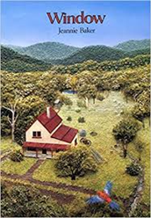 | 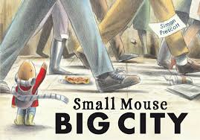
 | Window  By Jeannie Baker | Small Mouse Big City  By Simon Prescott
English: | Recounts; labels and captions; adventure narrative; instructions; emails and character studies.
Art and Design: | Mondrian, landscapes & cityscapes collages, portraits, Great Fire of London pictures and printing iconic landmarks.
Computing: | Searching the web; digital images; algorithms; logical reasoning; creating and debugging programs; common uses of information technology; communication; e-safety; stop motion animation
D&T: | Exploring mechanisms; constructing moving models, understanding where food comes from; design and make souvenirs; models of London landmarks and models of houses from Pudding Lane 1666.
Geography: | Countries and capital cities of the UK (London focus); using locational language; using maps; making own maps, looking at geographical similarities and differences and sustainability
History: | The significance of the Great Fire of London and Samuel Pepys
Mathematics: | White Rose Maths and Mastering Number
Music: | Traditional songs and nursery rhymes
PE: | Gymnastics and invasion games
PSHE: | Jigsaw
Science: | Everyday materials; working scientifically

