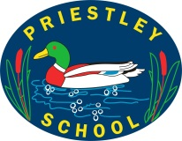

Cornerstones Framework

Priestley Primary School

EYFS Curriculum Overview

|  |  |  |  |  |  |  |
| --- | --- | --- | --- | --- | --- | --- |
| Spikey Values | Respect for All | | | | | |
| Take Responsibility | Cooperate | Think Things Through | Stay Focused | Give it a Go | Share Great Ideas |

|  |  |  |  |  |  |  |
| --- | --- | --- | --- | --- | --- | --- |
|  | Term 1 | Term 2 | Term 3 | Term 4 | Term 5 | Term 6 |
| *Cornerstones*  *Imaginative Learning Project* | Me & My Community  Exploring Autumn | Once Upon a Time  Sparkle & Shine | Ready Steady Grow    Signs of Spring | Animal Safari  Puddles & Rainbows | Big Wide World  Splash | On The Beach  Moving On |

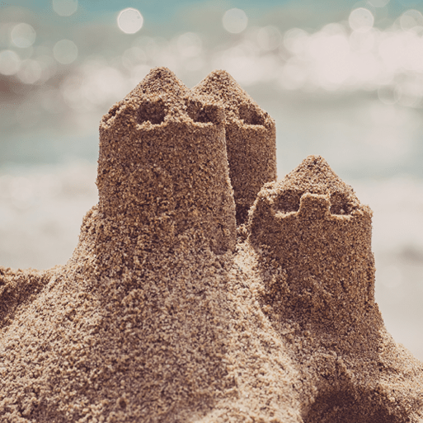

******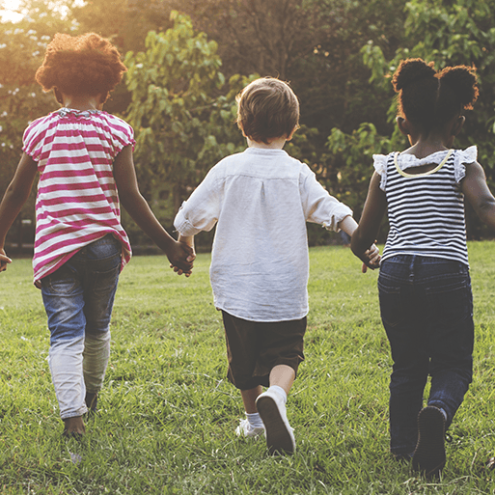**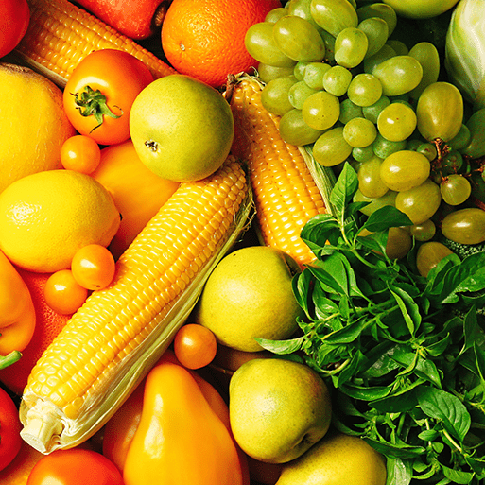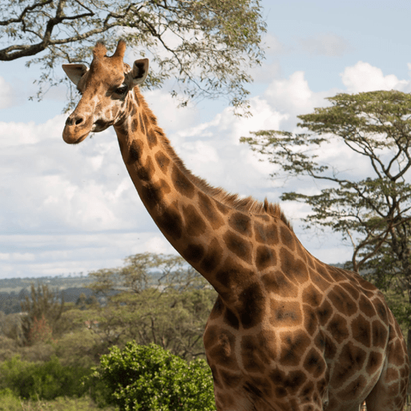

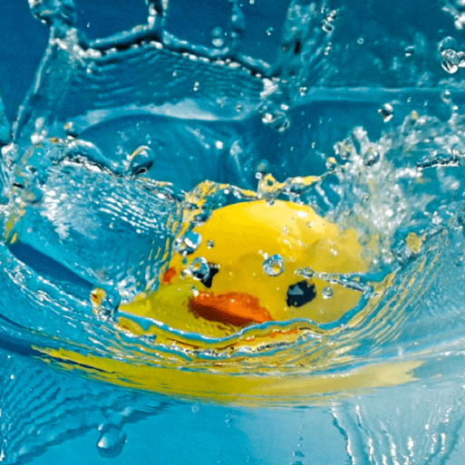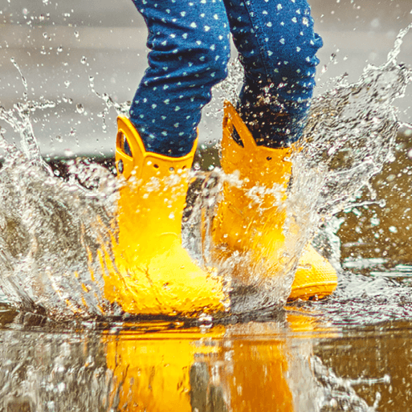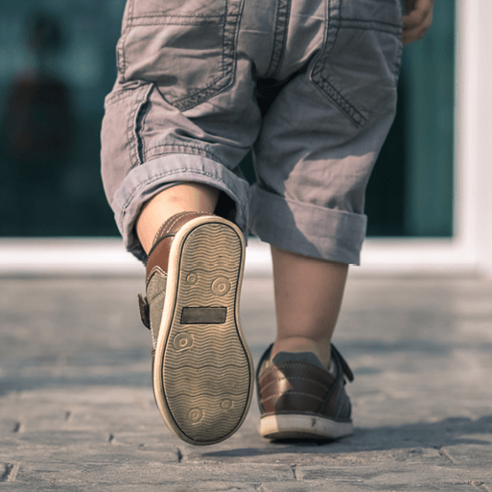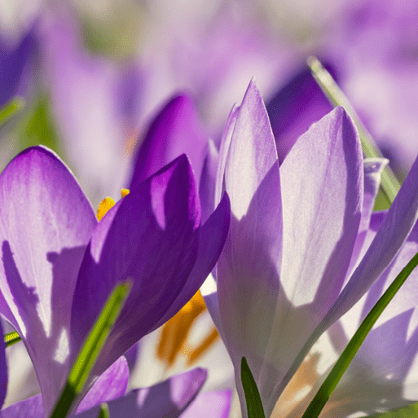

Suggested Enrichment Experiences

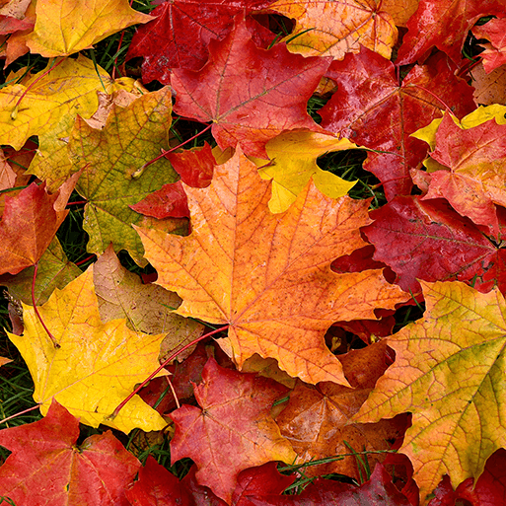

Suggested Enrichment Experiences

|  |  |  |  |  |  |
| --- | --- | --- | --- | --- | --- |
| Term 1 | Term 2 | Term 3 | Term 4 | Term 5 | Term 6 |
| ***Visit to the Library.***  ***Westonbirt Arboretum*** | **Panto!**  **Bonfire Stories** | **Roves Farm** | **Noah’s Ark Farm Zoo**  **World Book Day** | **River Trip** | **Cotswold Park and Beach** |

Term 1 Term 2 Term 3 Term 4 Term 5 Term 6

The Bookshelf

|  |  |  |  |  |  |
| --- | --- | --- | --- | --- | --- |
|  |  |  |  |  | Lucy and Tom at the Seaside - Lucy and Tom (Paperback) |
| The Wolf Who Wouldn’t Go to School  *(Whiffy Wilson)* | Little Red Riding Hood | Handa’s Surprise  *(Eileen Browne)* | Monkey Puzzle  *(Julia Donaldson)* | Fatou, Fetch the Water  *(Neil Griffith)* | *Lucy and Tom and the Seaside*  *(Shirley Hughes)* |
| The Lion and the Mouse by Mairi Mackinnon |  |  |  | Under the Same Sky (Paperback) | Hooray for Fish! (Paperback) |
| The Lion and the Mouse *(Mairi Mackinnon)* | The Three Little Wolves and the Big Bad Pig  (Eugene Trivias) | Daisy, Eat your Peas  *(Kes Gray)* | Doing the Animal Bop  *(Jan Ormerod)* | Under the Same Sky  *(Britta Teckenthrup)* | Hooray for Fish!  *(Lucy Cousins)* |
|  |  |  |  | Our World: A First Book of Geography (Board book) | Say Goodbye... Say Hello (Hardback) |
| Leaf Man  *(Lois Ehlert)* | The Three Billy Goat’s Gruff | Pass the Jam, Jim  *(Kaye Umansky)* | The Koala who Could  *(Rachel Bright)* | Our World, First Book of Geography  *(Sue Lowell Gallion)* | Say Goodbye…Say Hello*.*  *(Cori Doerrfeld)* |
|  |  |  |  | Commotion In The Ocean (Paperback) | Be Brave Little Penguin (Paperback) |
|  | The Jolly Christmas Postman  ***(Allan Ahlberg)*** | The Teeny Weeny Tadpole  ***(Sheridan Cain)*** | The Colour Monster  *(Anna Llenas)* | Commotion in the Ocean *(Giles Andreae)* | Be Brave Little Penguin  *(Giles Andreae)* |
|  |  |  |  | The Crocodile Who Didn't Like Water (Paperback) | Some Days (Hardback) |
|  |  | When Spring Comes ***(Kevin Henkes)*** | Mrs Noah’s Garden  *(Jackie Morris)* | *The Crocodile who Didn’t Like Water* ***(Gemma Merino)*** | Some Days  ***(Karen Kaufman Orloff)*** |

|  |  |  |  |  |  |
| --- | --- | --- | --- | --- | --- |
| EYFS |  |  |  |  |  |
| You Choose  (Nick Sharratt & Pippa Goodhart) | *Red Rockets and Rainbow Jelly*  (Sue Heap & Nick Sharratt) | *Blue Chameleon*  (Emily Gravett) | *The Family Book*  (Todd Parr) | Mommy, Mama and Me  (Leslea Newman) |
| *Saying what I think.* | *It’s OK to like different things.* | *Make friends with someone different.* | *Understand that all families are different.* | *Understanding that we share Celebrate my family.* |

9 Protective Characteristics

*Literacy lines of enquiry & exploration*

|  |  |  |  |  |  |
| --- | --- | --- | --- | --- | --- |
| Term 1 | Term 2 | Term 3 | Term 4 | Term 5 | Term 6 |
| ***Phonics***   * ***s,a,t,p,I,n,g,o,c,k,ck***   ***Tricky words***   * ***Recognising my name*** * ***Rhymes and alliteration.*** * ***Working from left to right.*** * ***Anticipating what might happen next in a story.*** | ***Phonics***   * ***ck e u r*** * ***h b f, ff l, ll ss*** * ***Orally blend and segment CVC words using the phase 2 phonemes***   ***Tricky words***   * ***the, no, go, I*** * ***Joining in with familiar stories.*** * ***Ordering and retelling simple stories.***   ***Writing***   * ***Giving it a go with our writing – writing with a purpose (lists and labels)*** * ***Describing characters*** | ***Phonics***   * ***j v w x*** * ***y z, zz qu*** * ***ch sh th ng***   ***Tricky words***   * ***me, be, he, my, by, they, she***   ***Writing***   * ***Writing simple sentences – phonetically plausible attempts.*** * ***Following recipes and writing simple instructions*** | * ***Phonics*** * ***ai ee igh oa oo (long) oo (short)*** * ***ar or ur ow oi*** * ***ear air ure er*** * ***Know the alphabet and then move on to sounds represented by more than one letter.*** * ***Learn letter names and how to read and spell tricky words.***   ***Tricky words***   * ***we, are, you, her, all, was.***   ***Writing***   * ***Write simple sentences using aids.*** | * ***Phonics*** * ***Adjacent Consonants*** * ***(cvcc, ccvc, ccvcc, cccvc, cccvcc)*** * ***Learn to read and spell words containing adjacent consonants.*** * ***Revise and recall all Phase 2 and 3 phonemes.*** * ***Read and write CCVC and CVCC words.***   ***Tricky words***   * ***said, have, like, so, do, some, come, were, there, little, one, when, out, what***   ***Writing***   * ***Captions.*** * ***Using capital letters and full stops when writing simple sentences.*** | * ***Phonics*** * ***Adjacent Consonants*** * ***(cvcc, ccvc, ccvcc, cccvc, cccvcc)*** * ***Learn to read and spell words containing adjacent consonants.***   + ***Revise and recall all Phase 2 and 3 phonemes.***   + ***Read and write CCVC and CVCC words.***   ***Tricky words***   * ***said, have, like, so, do, some, come, were, there, little, one, when, out, what***   ***Writing***   * ***Independent writing.*** |

|  |  |  |  |  |  |
| --- | --- | --- | --- | --- | --- |
| Term 1 | Term 2 | Term 3 | Term 4 | Term 5 | Term 6 |
| * ***High quality interactions, daily group discussions, sharing circles, PSHE times, stories, singing, role-play areas.*** * ***Listen and follow simple instructions.*** * ***Turn taking in conversation and interactions.*** * ***Building confidence to share our ideas.*** * ***Extending vocabulary:*** * ***Amount, size, capacity, pattern*** * ***Community, Harvest*** * ***Phonic*** | * ***High quality interactions, daily group discussions, sharing circles, PSHE times, stories, singing, role-play areas.*** * ***Listen and follow simple instructions.*** * ***Turn taking in conversation and interactions and building social conventions.*** * ***Share ideas with classmates.*** * ***Extending sentences.*** * ***Embedding new words in a range of contexts.***   ***Vocabulary:***   * ***Season, Nativity, Square, triangle, circle, rectangle*** | * ***High quality interactions, daily group discussions, sharing circles, PSHE times, stories, singing, role-play areas.*** * ***Embedding new words in a range of contexts.*** * ***Listen and follow simple instructions.*** * ***Talk partner work.*** * ***Speaking in a larger group.***   ***Vocabulary:***   * ***Seed, plant, root, celebration, recipe.*** * ***Developing descriptive words*** | * ***High quality interactions, daily group discussions, sharing circles, PSHE times, stories, singing, role-play areas.*** * ***Understanding what we have read.*** * ***Recalling and reciting Spring poems*** * ***Embedding new words in a range of contexts.***   ***Vocabulary:***   * ***Carnivore, herbivore, omnivore, habitat, reptile, Bud, blossom, spring, bulb, plant, life cycle.*** | * ***High quality interactions, daily group discussions, sharing circles, PSHE times, stories, singing, role-play areas.*** * ***Saying “hello” in different languages.*** * ***Embedding new words in a range of contexts.***   ***Vocabulary:***   * ***village, town, county, city, country, ocean, environment, recycle.*** | * ***High quality interactions, daily group discussions, sharing circles, PSHE times, stories, singing, role-play areas.*** * ***Embedding new words in a range of contexts.***   ***Vocabulary:***   * ***Beach, Tide, Safety, Habitat, Shore*** |

*Communication & Language lines of enquiry & exploration*

*Maths lines of enquiry & exploration*

|  |  |  |  |  |  |
| --- | --- | --- | --- | --- | --- |
| Term 1 | Term 2 | Term 3 | Term 4 | Term 5 | Term 6 |
| * ***Matching and sorting*** * ***Comparing amounts, size, mass and capacity*** * ***Counting songs and rhymes*** * ***Making patterns*** * ***Positional language*** | * ***Recognising shape 2D shapes – circles, triangles, squares, rectangles*** * ***Representing numbers 4, 5 and 6*** * ***Composition of numbers 4, 5 and 6*** * ***Number bonds to 5*** * ***Night and Day*** * ***Ordering key events during the day*** * ***Measuring time in simple ways*** | * ***Comparing numbers to 5- bigger, smaller, equal.*** * ***Equal and unequal groups*** * ***Number bonds to 5 using songs and resources such as Numicon.*** * ***Exploring mass and capacity.*** * ***Exploring the numbers 6,7 and 8.*** * ***Making pairs and combining two groups.*** | * ***9 and 10 – representation*** * ***1 less (numbers to 10)*** * ***Comparing numbers to 10*** * ***Bonds to 10*** * ***3D shape*** * ***Pattern*** | * ***Numbers beyond 10*** * ***Number patterns beyond 10*** * ***Ordering to 20*** * ***Unknown quantities when adding and taking away.*** * ***Capacity*** * ***Rotate and manipulate shapes.*** | * ***Doubling*** * ***Halving*** * ***Sharing*** * ***Odd and even*** * ***Problem solving*** |

*Personal, Social & Emotional lines of enquiry & exploration*

|  |  |  |  |  |  |
| --- | --- | --- | --- | --- | --- |
| Term 1 | Term 2 | Term 3 | Term 4 | Term 5 | Term 6 |
| ***Jigsaw: Being Me in My World***   * ***Getting to know me.*** * ***Making friends.*** * ***Looking after each other and being kind.*** * ***Class rules: Behavioural***   ***expectations and systems in the class/boundaries set.***   * ***Looking after our resources.*** * ***Introducing Spikey.*** * ***Building independence with changing and using the toilet.*** | ***Jigsaw: Celebrating Differences***   * ***Looking after our resources.*** * ***Building independence with changing and using the toilet.*** | ***Jigsaw: Dreams & Goals***   * ***Staying motivated when doing something challenging.*** * ***Never giving up.*** * ***Obstacles and support.*** | ***Jigsaw: Healthy Me***   * ***Being Brave.*** * ***Online safety.*** * ***What is a healthy diet?*** * ***What do I need to stay healthy?*** | ***Jigsaw: Relationships***   * ***Making friends and resolving conflicts.*** * ***Water safety.*** | ***Jigsaw: Changing Me***   * ***Understanding that everyone is special and unique.*** * ***Celebrating achievements.*** * ***Sun safety.*** * ***Sportsmanship.*** * ***Transition to Year 1.*** |

*Physical Development lines of enquiry & exploration*

|  |  |  |  |  |  |
| --- | --- | --- | --- | --- | --- |
| Term 1 | Term 2 | Term 3 | Term 4 | Term 5 | Term 6 |
| * ***Funky fingers finger gym.*** * ***Building pencil grip strength.*** * ***Handwriting preparation – large movements.*** * ***Use knives and forks to cut.*** * ***Holding and controlling a brush.*** * ***Holding a pencil.*** * ***Hand washing.*** * ***Exploring mark making with a range of equipment.*** * ***Handwriting - Curly caterpillar, ladder letter, one armed letters.*** * ***Getting changed*** * ***Finding a safe space to move in.*** * ***Stopping and going.*** * ***Exploring small scale equipment.*** | * ***Funky fingers finger gym.*** * ***Building pencil grip strength.*** * ***Handwriting preparation – large movements.*** * ***Holding scissors – single snips.*** * ***Use knives and forks to cut.*** * ***Handwriting - Curly caterpillar, ladder letter, one armed letters.*** * ***Getting changed*** * ***Finding a safe space to move in.*** * ***Dance – movement to music – using my whole body.*** | * ***Funky fingers finger gym*** * ***Handwriting – zigzag. letters.*** * ***Use knives and forks to cut.*** * ***Holding and controlling a brush.*** * ***Exploring mark making with a range of equipment.*** * ***Getting changed.*** * ***Gymnastics – jumping, balancing, rolling – floor work.*** | * ***Continuing to refine the size and formation of letters.*** * ***Getting changed*** * ***Dance – building a sequence of movements.*** * ***Levels of movement.*** | * ***Continuing to refine the size and formation of letters.*** * ***Using line guides*** * ***Getting changed*** * ***Gymnastics – large scale equipment – safety and control.*** | * ***Continuing to refine the size of letters.*** * ***Using line guides.*** * ***Getting changed.*** * ***Moving at speed.*** * ***Developing throwing.*** * ***Team races.*** |

|  |  |  |  |  |  |
| --- | --- | --- | --- | --- | --- |
| Term 1 | Term 2 | Term 3 | Term 4 | Term 5 | Term 6 |
| * ***People who help us in the community.*** * ***My family.*** * ***My school.*** * ***Harvest.*** * ***Native woodland animals; What is a wild animal?*** * ***Seasons – Autumn – what changes will begin to happen soon?*** | * ***Celebrations: Diwali, Hanukkah & Christmas*** * ***Seasons - Autumn*** * ***When were traditional tales written – how has life changed?*** * ***Nativity*** * ***Investigate - Light and dark.*** * ***Remembrance Day*** | * ***Celebrations: New Year & Chinese New Year.*** * ***E-safety day.*** * ***Investigate - Is it waterproof?*** * ***Weather watch.*** * ***Investigate - Rainbows*** * ***Fruits – where do they come from? What is a seed?*** | * ***Seasons – Spring*** * ***What is a habitat?*** * ***Lifecycles.*** * ***What do animals eat?*** * ***Investigate - camouflage.*** * ***Easter*** | * ***Children around the World – comparing language, food, houses, buildings.*** * ***Maps – making maps and understanding simple symbols.*** * ***Beebot – programming Beebot around a grid.*** * ***River habitats.*** * ***Water safety.*** * ***Investigate - Floating and Sinking.*** | * ***Who lives in a Rockpool?*** * ***Seaside holidays past and present.*** * ***Special places – churches, mosques, temples*** * ***Sea creatures around the world.*** * ***Seasons – Summer.*** * ***Recycling and ocean health.*** |

*Understanding the World lines of enquiry & exploration*

The Gallery

Term 2 Term 3 Term 5

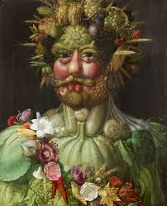

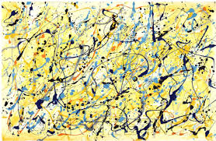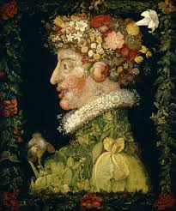

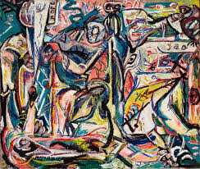

Vincent Van Gogh Giuseppe Archimboldo Jackson Pollock

|  |  |  |  |  |  |
| --- | --- | --- | --- | --- | --- |
| Term 1 | Term 2 | Term 3 | Term 4 | Term 5 | Term 6 |
| ***Art & Design***   * ***Exploring the make it area – being independent.*** * ***Transient autumnal art***   ***Music:***   * ***Learn to sing nursery rhymes and action songs:*** * ***Pat-a-cake, 1, 2, 3, 4, 5, Once I Caught A Fish Alive, This Old Man & Five Little Ducks.*** * ***Name Song*** * ***Things For Fingers*** * ***Listening and responding to different styles of music*** * ***Embedding foundations of the interrelated dimensions of music.*** * ***Learning to sing or sing along with nursery rhymes and action songs.*** * ***Improvising leading to playing classroom instruments.*** * ***Singing and learning to play instruments within a song.*** * ***Share and perform the learning that has taken place*** | ***Art & Design***   * ***Exploring the make it area – being independent.*** * ***Van Gogh - Starry Night collage.*** * ***Using and applying runny glue.*** * ***Exploring blue.*** * ***Building bridges for The Three Billy Goats Gruff*** * ***Making strong houses for the Three Little Pigs.*** * ***Puppet play***   ***Music:***   * ***Learn to sing nursery rhymes and action songs: I’m A Little Teapot, The Grand Old Duke Of York*** * ***Ring O’ Roses, Hickory Dickory Dock, Not Too Difficult & The ABC Song*** * ***Listening and responding to different styles of music.*** * ***Embedding foundations of the interrelated dimensions of music.*** * ***Learning to sing or sing along with nursery rhymes and action songs.*** * ***Improvising leading to playing classroom instruments.*** * ***Singing and learning to play instruments within a song.*** * ***Share and perform the learning that has taken place.*** | ***Art & Design***   * ***Exploring the make it area – being independent.*** * ***Exploring collage further – cutting shapes.*** * ***Giuseppe Acrimboldo - observation painting of fruits and vegetables, selecting appropriate colours.*** * ***Colour mixing*** * ***Wind chimes – construction and design***   ***Music:***   * ***Learn to sing nursery rhymes and action songs: Wind The Bobbin Up, Rock-a-bye Baby, Five Little Monkeys Jumping On The Bed, Twinkle Twinkle*** * ***If You're Happy And You Know It & Head, Shoulders, Knees and Toes.*** * ***Listening and responding to different styles of music*** * ***Embedding foundations of the interrelated dimensions of music.*** * ***Learning to sing or sing along with nursery rhymes and action songs.*** * ***Improvising leading to playing classroom instruments.*** * ***Singing and learning to play instruments within a song.*** * ***Share and perform the learning that has taken place.*** | ***Art & Design***   * ***Studying animal patterns – shapes, patterns, textures and colours.*** * ***Creating a simple printing block.*** * ***Using chalks – looking closely at feathers*** * ***Animal dens – clay (pinch, roll and cut) and natural materials.***   ***Music:***   * ***Learn to sing nursery rhymes and action songs:*** * ***Old Macdonald, Incy Wincy Spider, Baa Baa Black Sheep, Row, Row, Row Your Boat, The Wheels On The Bus & The Hokey Cokey.*** * ***Listening and responding to different styles of music*** * ***Embedding foundations of the interrelated dimensions of music.*** * ***Learning to sing or sing along with nursery rhymes and action songs.*** * ***Improvising leading to playing classroom instruments.*** * ***Singing and learning to play instruments within a song.*** * ***Share and perform the learning that has taken place.*** | ***Art & Design***   * ***Jackson Pollack - “Action painting”*** * ***Exploring the fluidity and dilution of paint.***   ***Music:***   * ***“Hello to All the Children of the World.” Song*** * ***Exploring musical instruments from around the world.*** * ***Listening and appraising Funk music.*** * ***Embedding foundations of the interrelated dimensions of music using voices and instruments.*** * ***Learning to sing Big Bear Funk and revisiting other nursery rhymes and action songs.*** * ***Playing instruments within the song.*** * ***Improvisation using voices and instruments.*** * ***Riff-based composition.*** * ***Share and perform the learning that has taken place.*** | ***Art & Design***   * ***Observational drawing of shells with pencil.*** * ***Water and sand landscape collage.*** * ***Creating boats from junk.*** * ***Making stained glass windows***   ***Music:***   * ***Consolidate the learning that has occurred during the year. All the learning is focused on revisiting chosen nursery rhymes and/or songs, a context for the History of Music and the very beginnings of the Language of Music*** |

*Expressive Arts & Design lines of enquiry & exploration*

